AI ASSISTED CODING
LAB ASSIGNMENT – 11.1
Student Name | HARSHITH PATHIPAKA
Batch | 05
Enrollment Number | 2503A52141
Course Code | 23CS002PC304
Course Title | AI Assisted Coding
Assignment | Lab 11 – Data Structures with AI: Implementing Fundamental Structures
Academic Year | 2026–2027

Task 1 – Stack Implementation
Requirement: Generate a Stack class with push, pop, peek, and is_empty methods, including docstrings.
The assignment explicitly requires these four methods and a functional implementation. fileciteturn1file0L49-L56

2.1 AI Prompt
Create a Python Stack class using a list.
Include push(), pop(), peek(), and is_empty() methods.
Add clear docstrings, handle an empty stack safely, and provide a small demonstration.

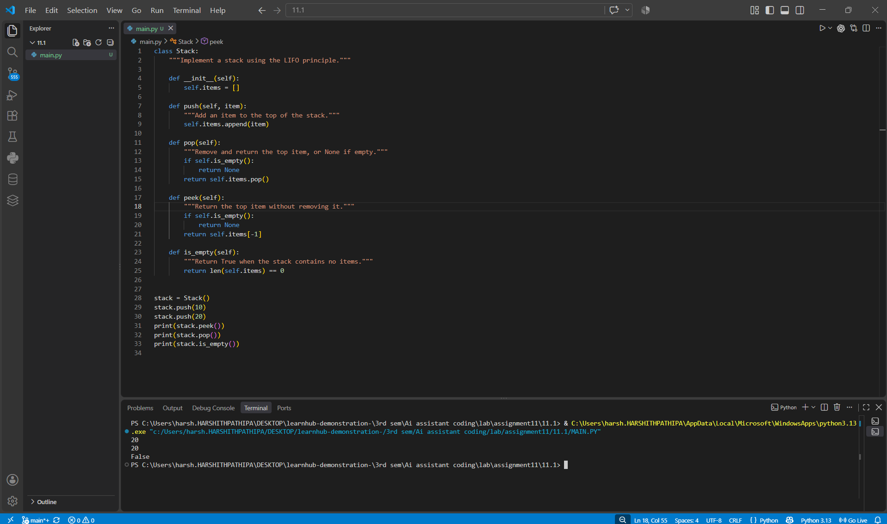
2.2 Implementation

2.3 output
20
20
False

3. Task 2 – Queue Implementation
Requirement: Implement a FIFO queue using Python lists with enqueue, dequeue, peek, and size.
The brief specifies FIFO behavior and these four methods. fileciteturn1file0L57-L63

3.1 AI Prompt
Implement a Queue class using a Python list.
Use FIFO behavior and provide enqueue(), dequeue(), peek(), and size().
Handle an empty queue and add docstrings and a demonstration.

3.2 Implementation

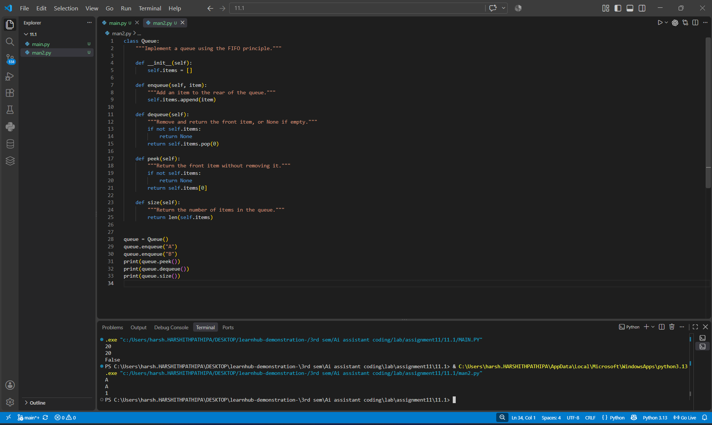3.3 Output
A
A
1

4. Task 3 – Singly Linked List
Requirement: Generate a singly linked list with insert and display methods.
The assignment asks for a working linked list with clear method documentation. fileciteturn1file0L64-L73

4.1 AI Prompt
Create a Python singly linked list using Node and LinkedList classes.
Implement insert() and display() methods.
Use clear docstrings and comments and demonstrate the output.

4.2 Implementation

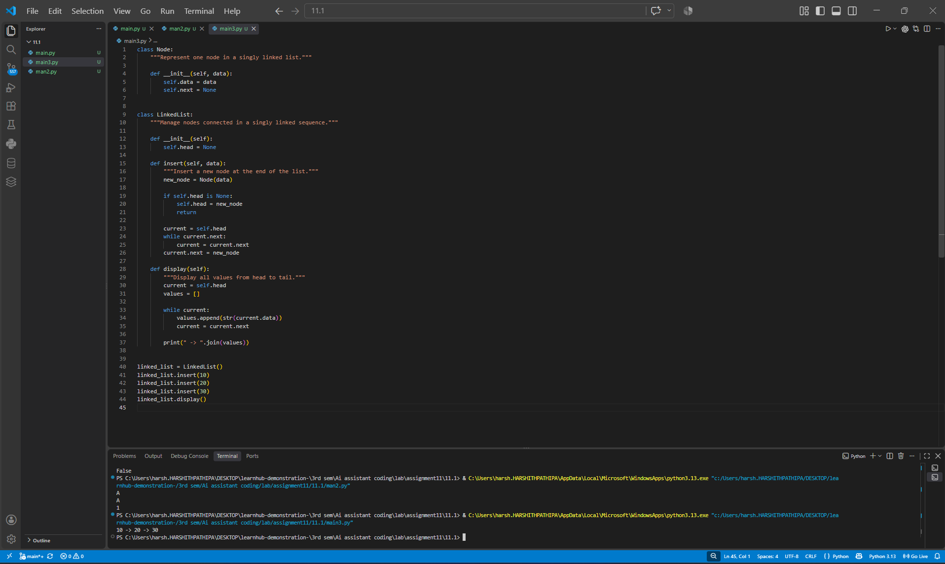4.3 Output
10 -> 20 -> 30

5. Task 4 – Binary Search Tree (BST)
Requirement: Create a BST with recursive insert and in-order traversal methods.
The brief requires recursive insertion and traversal. fileciteturn1file0L74-L81

5.1 AI Prompt
Create a Binary Search Tree in Python.
Use a recursive insert method and a recursive in-order traversal method.
Add docstrings and demonstrate the sorted traversal output.

5.2 Implementation

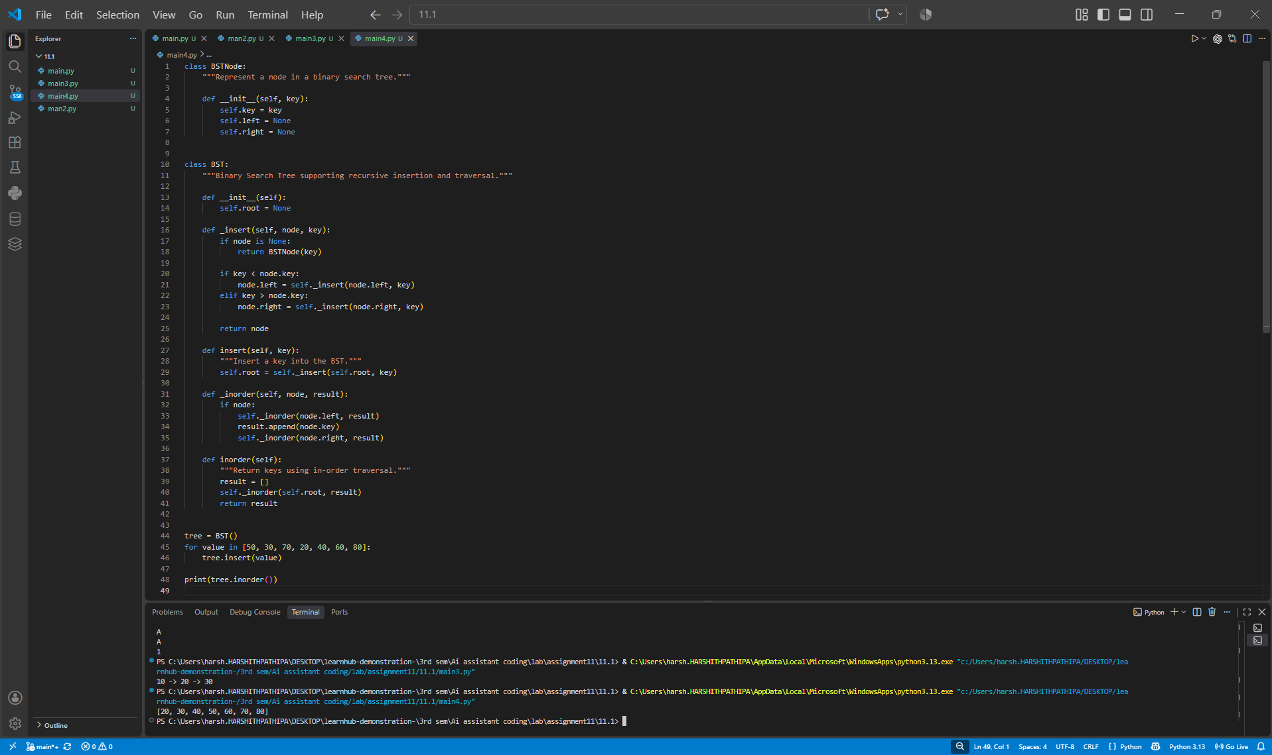5.3 Output
[20, 30, 40, 50, 60, 70, 80]

6. Task 5 – Hash Table
Requirement: Implement insert, search, and delete with collision handling using chaining.
The assignment specifically expects collision handling using chaining. fileciteturn1file0L82-L88

6.1 AI Prompt
Implement a basic hash table in Python with insert(), search(), and delete().
Handle collisions using chaining with lists.
Add comments/docstrings and demonstrate collision handling.

6.2 Implementation

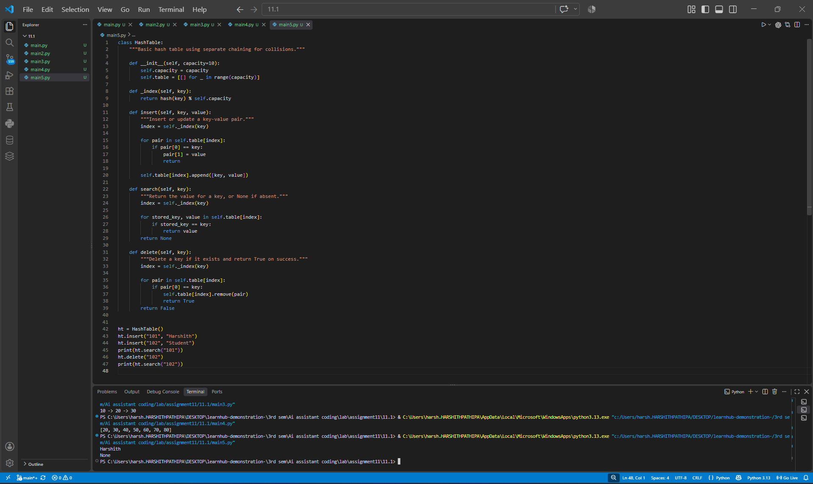6.3 Output
Harshith
None

7. Task 6 – Graph Representation
Requirement: Implement a graph using an adjacency list with add-vertex, add-edge, and display methods.
The expected graph implementation is an adjacency-list representation. fileciteturn1file0L89-L95

7.1 AI Prompt
Create a Python Graph class using an adjacency list.
Implement add_vertex(), add_edge(), and display().
Use an undirected graph, add docstrings, and show the connections.

7.2 Implementation

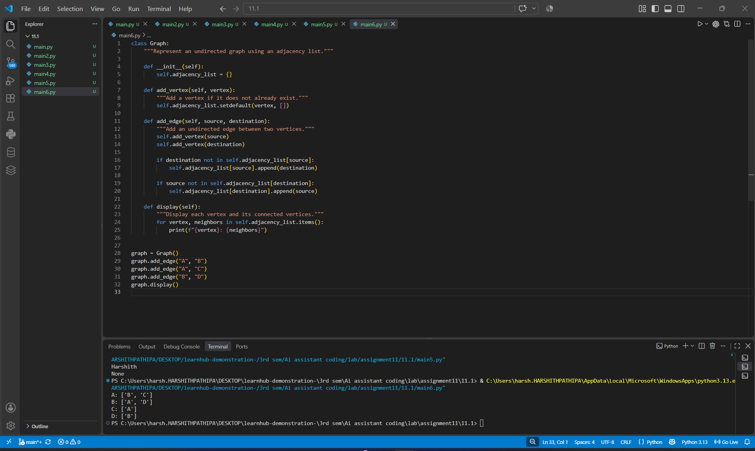7.3 Output
A: ['B', 'C']
B: ['A', 'D']
C: ['A']
D: ['B']

8. Task 7 – Priority Queue
Requirement: Use Python's heapq module to implement enqueue, dequeue, and display.
The brief specifies heapq and highest-priority dequeue behavior. fileciteturn1file0L96-L103

8.1 AI Prompt
Implement a priority queue using Python's heapq module.
Provide enqueue(item, priority), dequeue(), and display().
Treat a smaller numeric priority as higher priority and document the methods.

8.2 Implementation

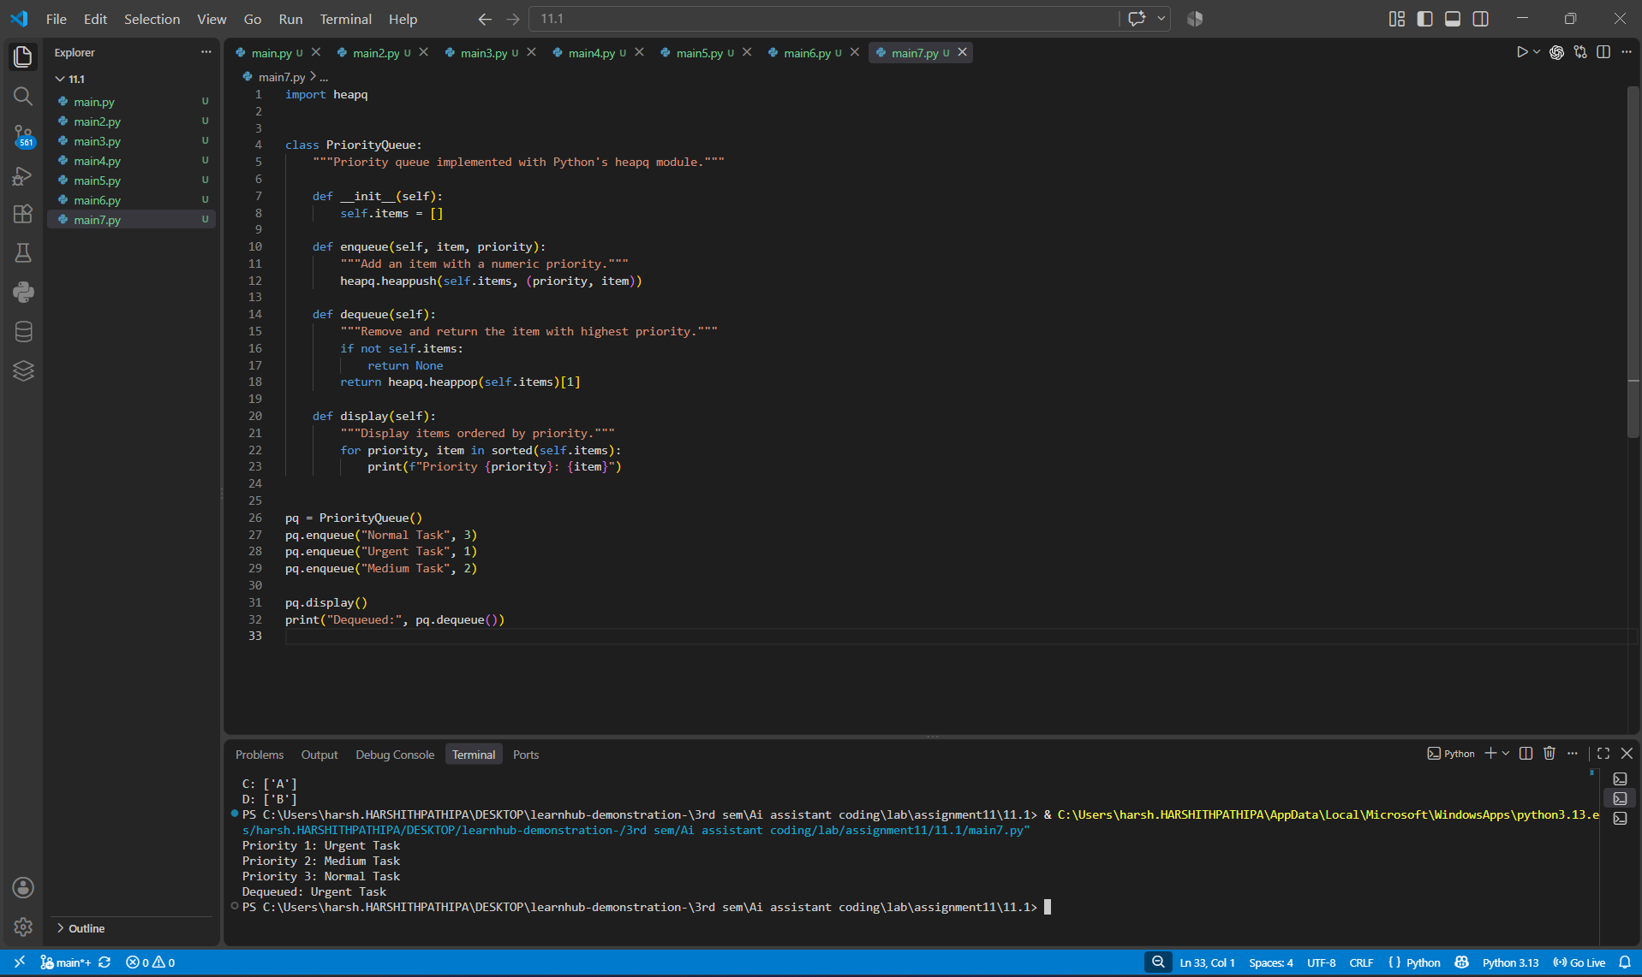8.3 Output
Priority 1: Urgent Task
Priority 2: Medium Task
Priority 3: Normal Task
Dequeued: Urgent Task

9. Task 8 – Deque
Requirement: Implement a double-ended queue using collections.deque, supporting insertion and removal at both ends.
The assignment specifies collections.deque and operations from both ends. fileciteturn1file0L104-L109

9.1 AI Prompt
Create a DequeDS class using collections.deque.
Implement add_front(), add_rear(), remove_front(), remove_rear(), and display().
Handle empty removal safely and include docstrings.

9.2 Implementation

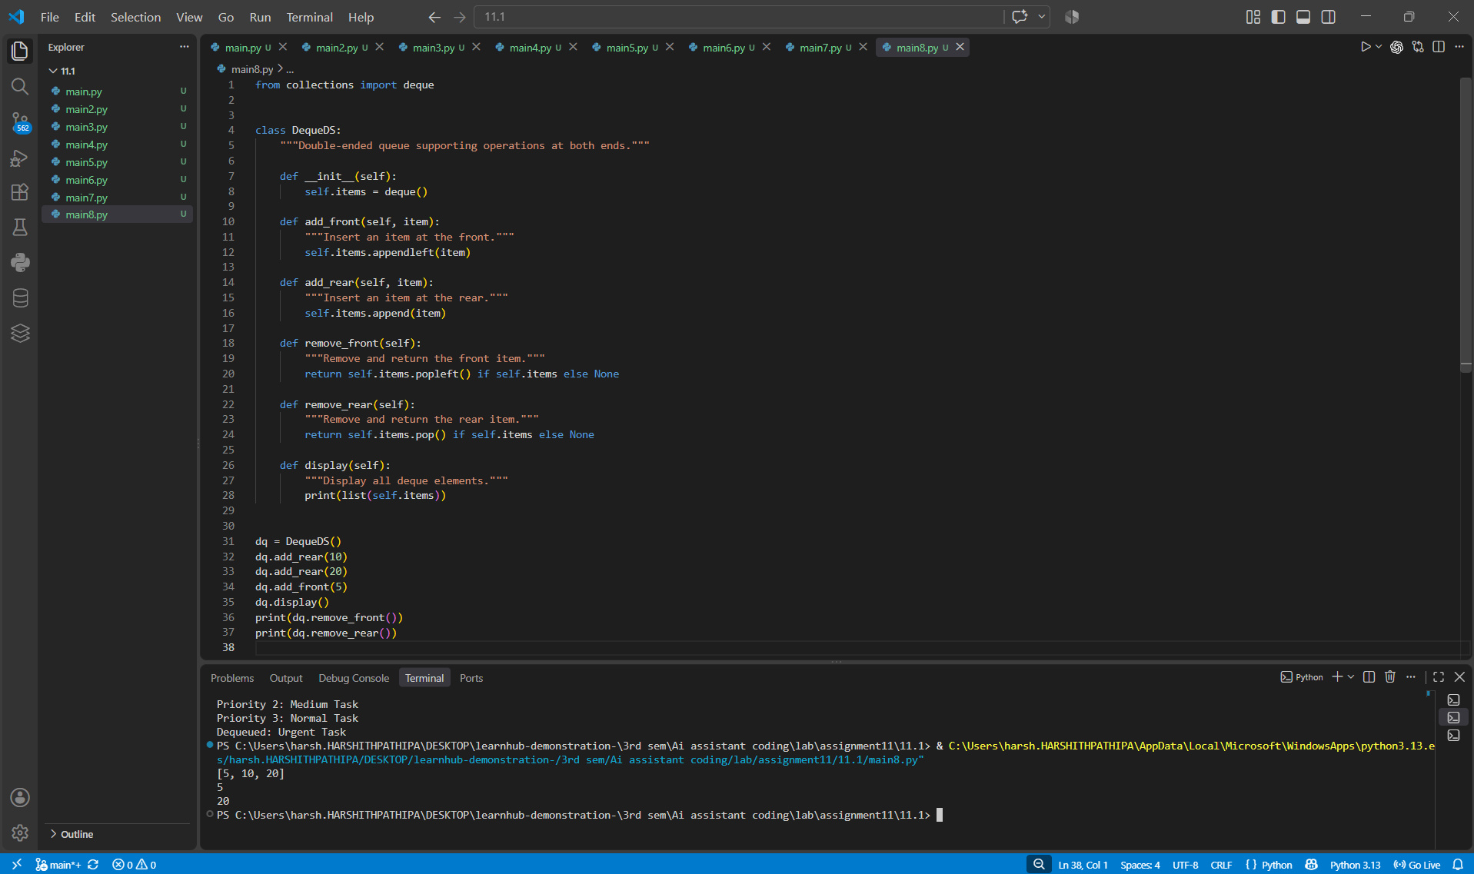9.3 Output
[5, 10, 20]
5
20

10. Task 9 – Real-Time Campus Resource Management System
The scenario covers student attendance, event registration, library borrowing, bus scheduling, and cafeteria orders. The task requires a data-structure mapping, 2–3 sentence justifications, and one working implementation.
The supplied brief lists the five campus features and the permitted structures, then asks for one feature to be implemented. fileciteturn1file0L112-L139

10.1 Data Structure Selection
Feature | Chosen Data Structure | Justification
Student Attendance Tracking | Deque | Attendance records may need entries added at the rear while recent records can be inspected or removed from either end. A deque provides efficient operations at both ends.
Event Registration System | Hash Table | Participants can be associated with IDs or registration numbers for fast lookup and removal. Hash-table average-case lookup is efficient for this use.
Library Book Borrowing | Priority Queue | Books or borrowing records can be prioritized by due date so the most urgent returns can be processed first.
Bus Scheduling System | Graph | Bus routes and stops naturally form vertices and connections. A graph represents relationships between stops and routes effectively.
Cafeteria Order Queue | Queue | Students should be served in the order they arrive. A FIFO queue directly models this behavior.

10.2 Selected Feature – Cafeteria Order Queue
A Queue is selected because cafeteria orders are served in first-in, first-out order.

10.3 AI Prompt
Build a Python cafeteria order management system using a Queue.
Orders must be processed in the order received.
Include enqueue_order(), serve_order(), and display_orders(), with comments,
docstrings, and a demonstration.

10.4 Working Python Program

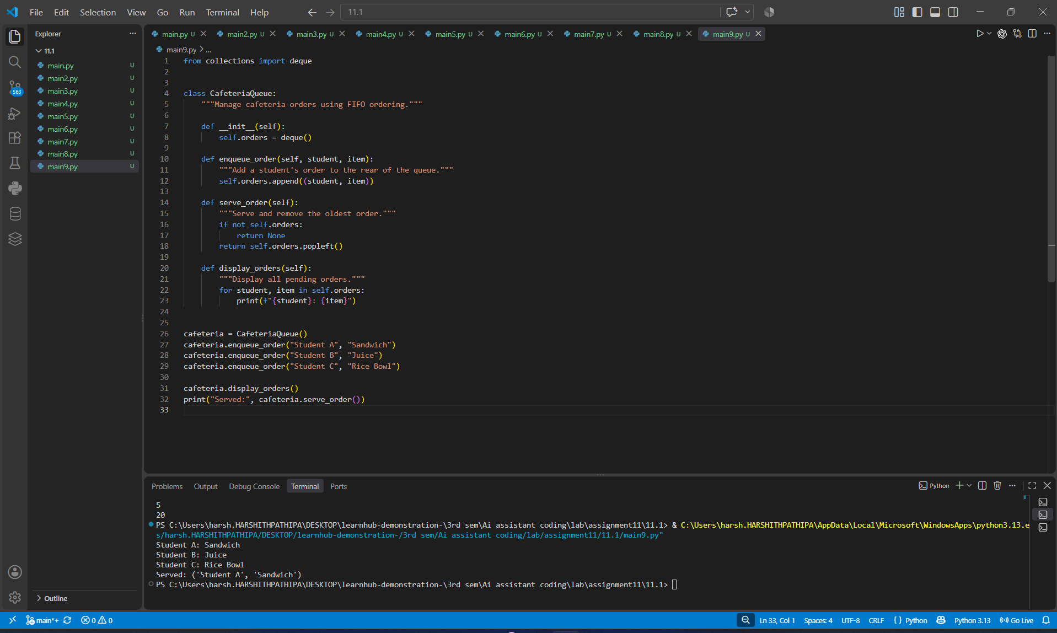10.5 Output
Student A: Sandwich
Student B: Juice
Student C: Rice Bowl
Served: ('Student A', 'Sandwich')

11. Task 10 – Smart E-Commerce Platform
The e-commerce scenario contains shopping cart management, order processing, top-selling products tracking, product search, and delivery route planning. The task requires a structure mapping, justifications, and one implementation.
The supplied brief defines these five features and requires each to be mapped to an appropriate data structure. fileciteturn1file0L143-L167

11.1 Data Structure Selection
Feature | Chosen Data Structure | Justification
Shopping Cart Management | Deque | Products need to be added and removed dynamically, potentially from either end. A deque supports efficient insertion and removal at both ends.
Order Processing System | Queue | Orders are processed in the order they are placed. FIFO queue behavior directly represents this requirement.
Top-Selling Products Tracker | Priority Queue | Products can be prioritized by sales count so highly ranked products can be retrieved efficiently.
Product Search Engine | Hash Table | Product IDs provide natural keys for direct lookup. A hash table provides average O(1) key lookup.
Delivery Route Planning | Graph | Warehouses and delivery locations are nodes connected by routes. A graph models these connections and supports route-related operations.

11.2 Selected Feature – Product Search Engine
A Hash Table is selected because a product ID can be used as a key for fast product lookup.

11.3 AI Prompt
Create a Python product search engine using a Hash Table.
Use product IDs as keys and store product information as values.
Implement insert_product(), search_product(), and delete_product().
Add docstrings and demonstrate fast lookup.

11.4 Working Python Program

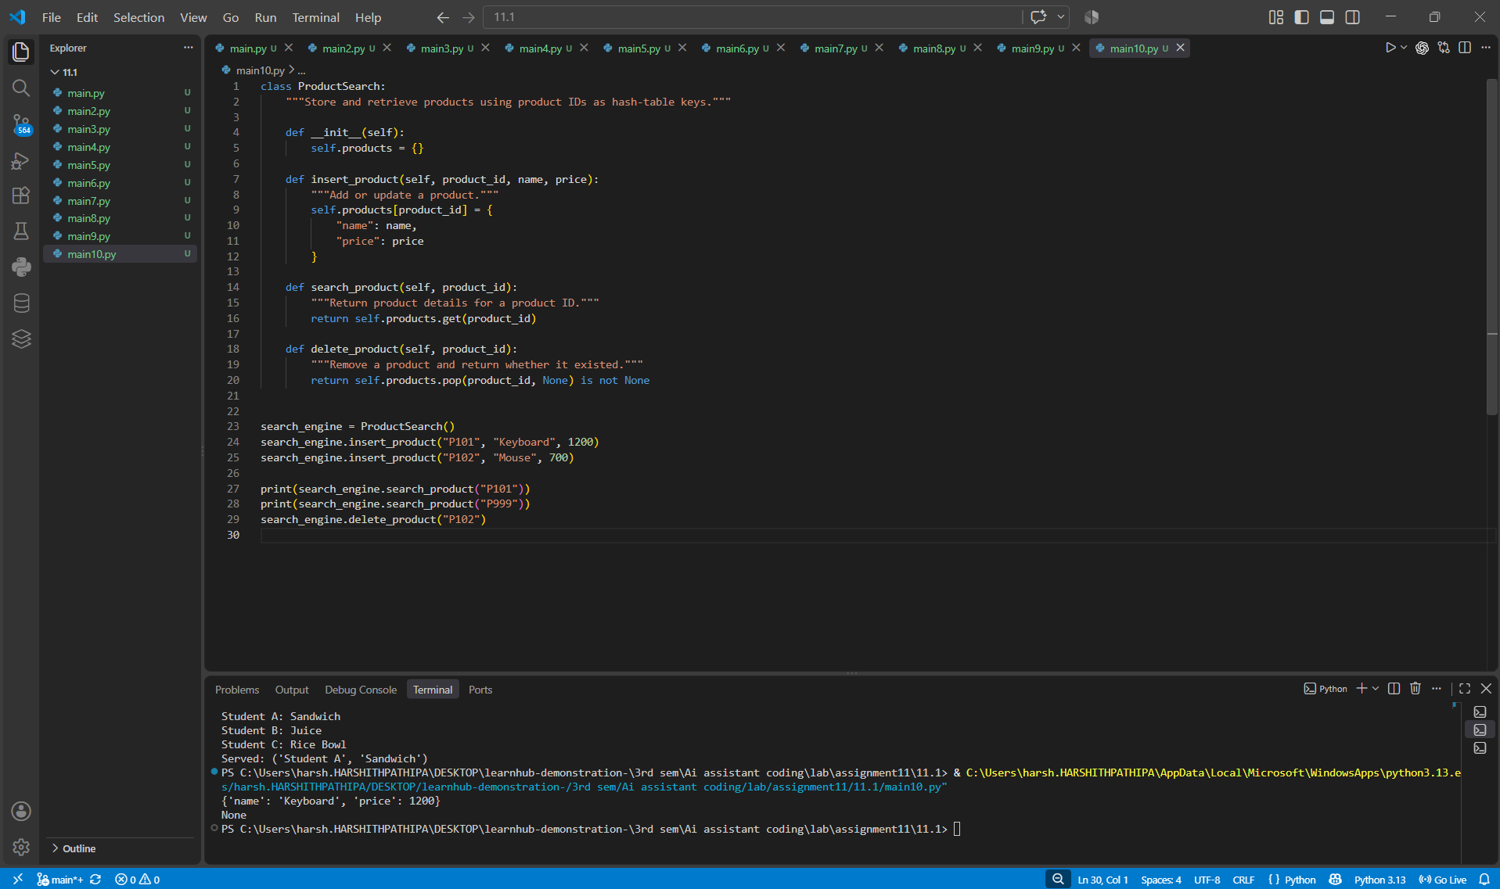11.5 Output
{'name': 'Keyboard', 'price': 1200}
None

12. Data Structure Comparison
Data Structure | Core Principle | Typical Strength | Used In
Stack | LIFO | Fast top insertion/removal | Task 1
Queue | FIFO | Ordered processing | Task 2, Campus cafeteria, E-commerce orders
Linked List | Node-based sequence | Dynamic sequential storage | Task 3
BST | Ordered tree | Ordered search/traversal | Task 4
Hash Table | Key-value hashing | Fast average lookup | Task 5, Event/Product search
Graph | Vertices and edges | Relationships/routes | Task 6, Bus/Delivery routes
Priority Queue | Priority ordering | Process highest-priority item first | Task 7, Top-selling tracker
Deque | Both ends | Fast front/rear operations | Task 8, Shopping cart

13. Conclusion
This lab demonstrates how AI can assist in implementing fundamental data structures while also producing documentation and clear demonstrations. The eight basic structures were implemented, followed by practical data-structure selection for campus-resource and e-commerce scenarios. The final implementations show how the choice of data structure should follow the operations and behavior required by the application.

